ORDER

OF THE

HOLY MASS

**Please Put**

**Beautiful Picture Here**

**☺**

Ordinary Time 2

September - November

“Theme”

_ Sunday in Ordinary Time

MM DD, 20YY

Processional

**Please stand**

*Selection per Parish or Mission*

Acclamation

The Ministers face the Presider, while the Presider faces the people and proclaims:

**Presider: Blessed be God: Father, Son, and Holy Spirit;**

*People: And blessed be His Kingdom, now and forever.* ***Amen.***

Collect for Purity

**Presider: Let us pray.**

Clergy face the Altar. Miter off.

**Almighty God, to You all hearts are open,**

**all desires known, and from You no secrets are hid.**

**Cleanse the thoughts of our hearts ✠**

**by the inspiration of Your Holy Spirit,**

**that we may perfectly love You**

**and worthily magnify Your holy Name;**

**through Christ our Lord.**

***All: Amen.***

Penitential Rite

The Summary of the Law and the Invitation to Confession are spoken by the Deacon in a high mass.

Deacon faces the people.

Summary of the Law

**Deacon: Jesus said, “The first Commandment is this:**

**Hear, O Israel: the Lord our God, the Lord is one. Love the Lord Your God with all your heart, with all your soul, with all your mind, and with all your strength.**

**The second is this: Love your neighbor as yourself. There is no other commandment greater than these.**

**Deacon: Dearly beloved, let us come into the presence of the Almighty God, praying together as we bow our hearts:**

Deacon faces the Altar. Deacon leads the prayer, in unison:

Confession

***All: Most merciful God, I confess that I have sinned against You in thought, word, and deed, by what I have done, and by what I have left undone. I have not loved You with my whole heart; I have not loved my neighbor as myself. I am truly sorry and I humbly repent. For the sake of Your Son Jesus Christ, have mercy on me and forgive me; that I may delight in Your will, and walk in Your ways, to the glory of Your Name. Amen.***

Absolution

Presider faces the people.

**Presider: Almighty God have mercy on you, ✠ forgive you all your sins through our Lord Jesus Christ, strengthen you in all goodness, and by the power of the Holy Spirit keep you in eternal life.**

***All: Amen.***

**Please stand**

Glory in the Highest (*Gloria in Excelsis*)

The Presider censes the Altar and then the Deacon of the Mass censes the Ministers.

*Arrangement per parish or mission*

Collect of the Day Proper _____ CEC

Presider faces the people.

**Presider: The Lord be with you.**

*People: And with your spirit.*

**Presider: Let us pray.**

Presider and Ministers face the Altar.

The Collect of the Day is taken from the Proper for that Sunday or feast day.

**Presider:** *According to designated Proper*

***All: Amen.***

Presider goes to the back of the Altar, kisses it, and goes to his chair.

**Please be seated**

Liturgy of the Word

First Proclamation

Proclaimer: A Proclamation of the Word of God from …

*According to the designated Proper*

Proclaimer: The Word of the Lord.

***People: Thanks be to God!***

Responsorial Psalm:

*According to the designated Proper*

Proclaimer: Please stand for the Responsorial Psalm, which

1. today is … *(if the entire psalm is read)*
2. is taken from … *(if only a portion of the psalm is read)*

All stand and the Proclaimer leads the people in the Responsorial Psalm followed by the *Gloria Patri*.

*Gloria Patri* (BCP, Rite II)

The *Gloria Patri* may be spoken or sung in unison. The Proclaimer and Altar Ministers remain in their places, face the Altar, and bow.

***All: Glory to the Father, and to the Son, and to the Holy Spirit:* ✠**

***As it was in the beginning, is now, and will be forever. Amen.***

A Choral Response may be sung here.

*Selection per Parish or Mission*

**Please be seated.**

Second Proclamation

Proclaimer: A Proclamation of the Word of God from …

*According to the designated Proper*

The proclaimer reads the second appointed lesson of the day.

Proclaimer: The Word of the Lord.

***People: Thanks be to God!***

**Please stand.**

Gradual Verse

Proclaimer: *According to the designated Proper*

Miter on. Bless the Gospel Proclaimer.

Gradual Hymn

*Selection per Parish or Mission*

Gospel Acclamation

Miter Off.

Deacon: The Lord be with you.

*People: And with your spirit.*

Deacon: May the Lord be on our **✠** minds, on our **✠** lips, and on our **✠** hearts as we hear **✠** His Holy Gospel.

The Holy Gospel of our Lord Jesus Christ according to Saint ….

*People: Glory to You, Lord Christ!*

Gospel Proclamation

The appointed Gospel is read by a Deacon.

*According to the designated Proper*

*Deacon: The Gospel of the Lord.*

***People: Praise to You, Lord Christ!***

All sit.

Homily

**Please stand**

Nicene Creed

***All: We believe in one God, the Father Almighty, Maker of Heaven and earth, and of all things: visible and invisible.***

***And in one Lord, Jesus Christ, the only begotten Son of God, begotten of His Father before all worlds;***

***God of God, Light of Light, very God of very God***

***begotten, not made, being of one substance with the Father;***

***by Whom all things were made;***

***Who for us men and for our salvation came down from Heaven;***

***and was incarnate by the Holy Spirit and the Virgin Mary, and was made man;***

***And was crucified also for us under Pontius Pilate;***

***He suffered death and was buried, and rose again on the third day, in accordance with the Scriptures;***

***and ascended into Heaven, and is seated on the right hand of the Father;***

***and He shall come again, with glory, to judge the living and the dead;***

***Whose Kingdom shall have no end.***

***And we believe in the Holy Spirit the Lord, and Giver of Life, Who proceeds from the Father;***

***Who with the Father and the Son together is worshiped and glorified;***

***Who has spoken through the prophets.***

***And we believe one holy catholic and apostolic Church;***

***We acknowledge one baptism for the remission of sins;***

***and we look for the resurrection of the dead, and the life of the world to come. Amen.* ✠**

Prayers of the People Form III (CEC)

The Deacon begins the Prayers of the People. The Minister continues.

Deacon: Let us pray for the whole state of Christ’s Church, and for the world.

Minister: Father, we pray for Your holy Catholic Church;

*People: That we all may be one.*

Minister: Grant that every member of the Church may truly and humbly serve You;

*People: That Your Name may be glorified by all people.*

Minister: We pray for all bishops, priests, and deacons, especially Bishop Craig and Bishop Ariel;

*People: That they may be faithful ministers of Your Word and Sacraments.*

Minister: We pray for all who govern and hold authority in the nations of the world, especially President Marcos;

*People: That there may be justice and peace on the earth.*

Minister: Give us grace to do Your will in all that we undertake;

*People: That our works may find favor in Your sight.*

Minister: Have compassion on those who suffer from any grief or trouble;

*People: That they may be delivered from their distress.*

Minister: Give to the departed eternal rest;

*People: Let light perpetual shine upon them.*

Minister: We praise You for Your saints who have entered into joy;

*People: May we also come to share in Your heavenly Kingdom.*

Deacon: Hear, O Lord, the cry of this people;

*People: As we lift to You our Corporate Petition.*

Corporate Petition

***Almighty God and King,***

***our dwelling place in all generations,***

***owner of the earth and all it contains:***

***Grant unto us our allotted inheritance, we pray,***

***and the grace to build upon it***

***facilities in which Your people,***

***being restored in Your image***

***and ever-growing in love for You,***

***might become a habitation of Your presence***

***and ministers of Your life,***

***to the glory of Jesus Christ our Lord;***

***Who lives and reigns together with You***

***and the Holy Spirit, one God,***

***now and forever.*** ***Amen.***

Alternatively, the Prayers of the Faithful included in the Proper for this Sunday or other feast may be prayed instead.

Refer to the Proper provided.

Corporate Petition

Concluding Collect

**Presider:** *According to the designated Proper*

***All: Amen.***

Peace

**Presider: The peace of the Lord be always with you.**

*People: And with your spirit.*

**Presider: Let us offer one another a sign of God’s peace.**

Offertory

Presider gives the Offering Exhortation.

Worship in Psalms,

Hymns,

and Spiritual Songs:

The Sacrifice

of Praise

The Offertory:

The Sacrifice

of Ourselves

*Selection per parish or mission*

The Lesser Doxology may be sung in a high mass, during which time the Presider censes the gifts.

After the Altar and Gifts have been censed by the Presider, the Deacon censes the Ministers, then all of the people.

Then Presider censes the front of the Altar and the Ministers again.

Lesser Doxology

*(Traditional)*

*(Words and Music By: Thomas Ken)*

*(Attributed To Louis Bourgeois)*

*Praise God from Whom all blessings flow,*

*Praise Him all creatures here below;*

*Praise Him above, ye heavenly Host:*

*Praise Father, Son and Holy Ghost!*

*AMEN!*

Preparation of the Gifts

Standing behind the Altar, the Presider takes the paten with the bread or a large host, and, holding it slightly raised above the altar, says:

**Presider: Blessed are You Lord, God of all creation. For through Your goodness we have received the bread we offer You: fruit of the earth and work of human hands, it will become the Body of Christ.**

*People: Blessed be God forever.*

While pouring a small amount of water into the chalice and flagon, the Presider says quietly:

**Presider: By the mystery of this water and wine may we come to share in the divinity of Christ, who humbled Himself to share in our humanity.**

Then the Presider takes the chalice and, holding it slightly raised above the altar, says:

**Presider: Blessed are You Lord, God of all creation, for through Your goodness we have received the wine we offer You, fruit of the vine and work of human hands; it will become the Blood of Christ.**

*People: Blessed be God forever.*

Then the Presider takes an offering basket or bag, and while holding it slightly raised above the altar, says:

**Presider: Blessed are You Lord, God of all creation, for through Your goodness we bring these tithes and offerings before You. They will be used in Your church for the work You have set before us and the furthering of Your kingdom.**

Presider places the offering below the altar, then washes his hands, quietly saying:

**Presider: Wash me, O Lord, from my iniquity and cleanse me from my sin.**

Exhortation To Pray (*Orate fratres*)

The Presider returns to the center of the altar, faces the people, and says:

**Presider: Pray, brothers and sisters, that our sacrifice may be acceptable to God, the Father Almighty.**

*People: May the Lord accept the sacrifice at your hands for the praise and glory of His name, for our good and the good of all His holy Church.*

***All: Amen.***

Great Thanksgiving

**Presider: The Lord be with you.**

*People: And with your spirit.*

**Presider: Lift up your hearts.**

*People: We lift them up to the Lord.*

**Presider: Let us give thanks to the Lord our God.**

*People: It is right to give Him thanks and praise.*

Preface ____ Ordinary CEC

The priest continues the preface with hands extended:

**Presider:** *According to the designated Proper*

Sanctus Benedictus

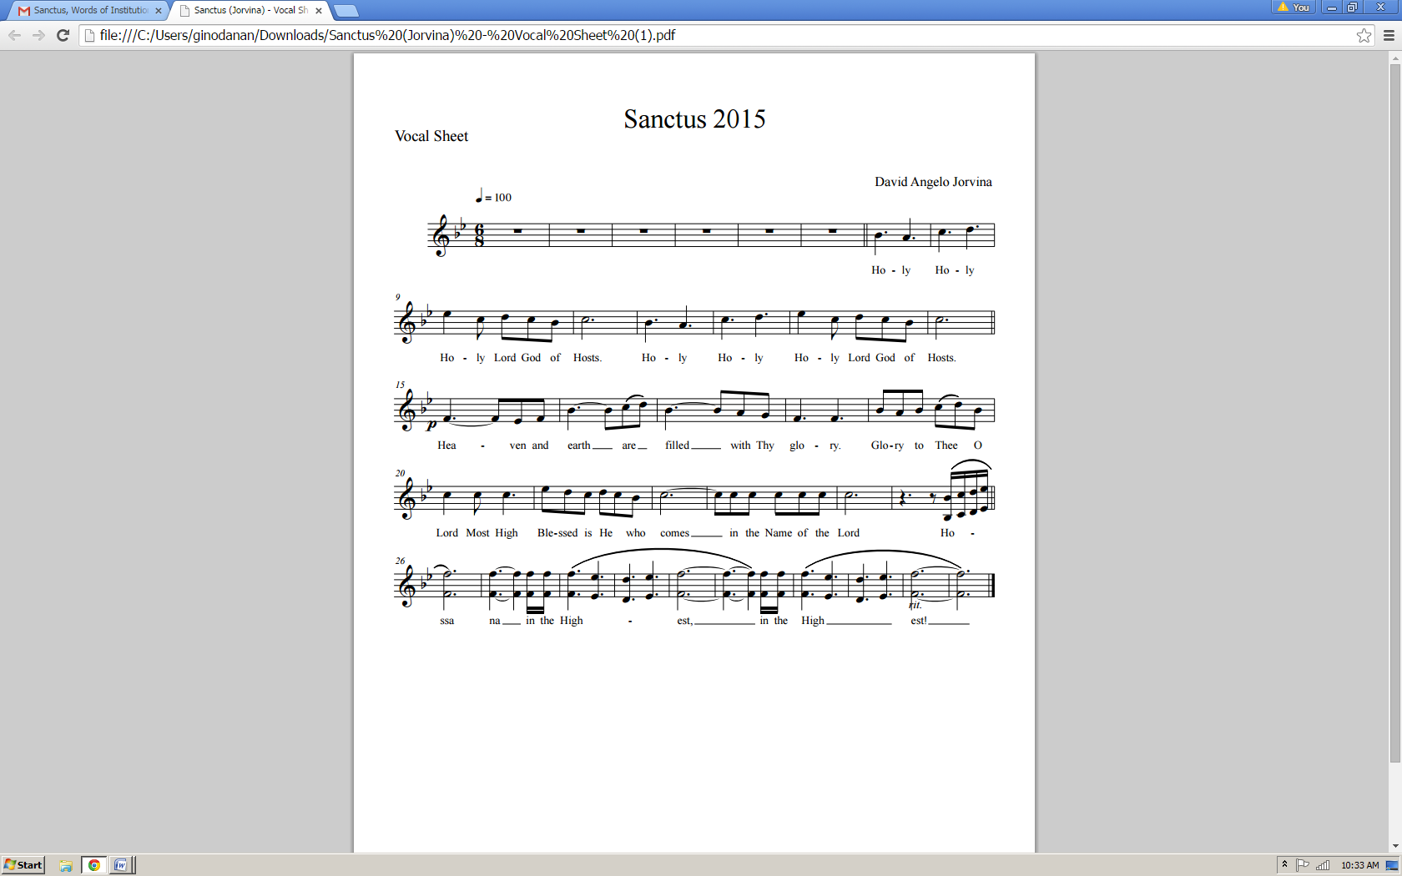

Eucharistic Prayer III CEC

**Presider: Father, You are holy indeed, and all creation rightly gives You praise. All life, all holiness comes from You through Your Son, Jesus Christ our Lord, by the working of the Holy Spirit.**

**And You never cease to gather a people to Yourself, so that from the rising of the sun to its setting a pure sacrifice may be offered to Your Name.**

**Epiclesis**

Please kneel (In the Cathedral, omit this for now)

The Presider joins his hands, then, holding them outstretched over the offerings, says:

**Presider: Therefore, O Lord, we humbly implore You: by the same Spirit graciously make holy these holy gifts we have brought to You for consecration, that they may become**

The Presider joins his hands, then makes the sign of the cross once over both bread and chalice, and says:

**Presider: the** ✠ **Body and Blood of Your Son, Jesus Christ, at Whose command we celebrate these mysteries.**

**Anamnesis**

**Presider: On the night He was betrayed, He took bread and gave You thanks and praise. He broke the bread, gave it to His disciples, and said:**

**“Take, eat: this is My body, which is for you; do this for the remembrance of Me.”**

The Presider shows the consecrated host to the people, places it on the paten, and bows or genuflects in adoration.

**Presider: When supper was ended, He took the cup. Again, He gave You thanks and praise, gave the cup to His disciples, and said:**

**“Drink this, all of you. This is My Blood of the New Covenant, which is shed for you and for many for the forgiveness of sins. Whenever you drink it, do this for the remembrance of Me.”**

(The Presider shows the consecrated chalice to the people, places it on the corporal, and bows or genuflects in adoration.)

(Please stand)

**Mysterium Fidei**

**Presider: Let us proclaim the mystery of faith.**

***All: Christ has died, Christ is risen, Christ will come again!***

**Oratio Pro Ecclessia**

**Presider: Father, calling to mind the death Your Son endured for our salvation, His glorious resurrection and ascension into Heaven, and as we look forward to His second coming, we offer You in thanksgiving this holy and living sacrifice.**

**Look with favor on Your Church’s offering, and recognizing the sacrificial Victim Whose death has reconciled us unto Yourself, grant that we, who are nourished by His Body and Blood, may be filled with the Holy Spirit, and become one body in Christ.**

**May He make us an everlasting gift to You and enable us to share in the inheritance of Your saints, with Blessed Mary, the mother of Jesus Christ our Lord and God, Joseph her husband, the apostles, the martyrs, and all Your saints, on whose constant intercession in Your presence we rely for unfailing help.**

**Strengthen in faith Your Church on earth, along with Your servant Craig, our Patriarch, our own Bishop, Ariel, and all the bishops, with the clergy and the entire people Your Son has gained for You.**

**Presider: Listen graciously to the prayers of this family whom You have summoned before You: In Your compassion, O merciful Father, gather to Yourself all Your children scattered throughout the world, through Jesus Christ our Lord, from whom all good things come.**

The Presider takes the chalice and the host and, lifting them up, says:

**Presider: By Him, with Him, and in Him, in the unity of the Holy Spirit, all honor and glory is Yours, almighty Father, now and forever.**

***All: Amen.***

The Presider continues:

**Presider: And now as our Savior Christ taught us, we are bold to pray.**

*THE LORD’S PRAYER*

*Our Father, Who art in heaven,*

*Hallowed be Thy Name;*

*Thy kingdom come;*

*Thy will be done on earth as it is in heaven.*

*Give us this day our daily bread.*

*And forgive us our trespasses,*

*As we forgive those who trespass against us.*

*And lead us not into temptation,*

*But deliver us from evil.*

*For Thine is the Kingdom, and the power,*

*And the glory; forever, and ever.*

*AMEN.* ✠

Breaking of the Bread

The Presider breaks the consecrated host in half, then breaks off a small piece and places it in the chalice.

Christ our Passover (*Pascha Nostrum*)

The Christ our Passover (*Pascha Nostrum*) may be spoken or sung in unison, or antiphonally by the Presider and the People.

**Presider: Hallelujah!**

**Christ our Passover is sacrificed for us!**

*People: Therefore, let us keep the feast. Hallelujah!*

**- or –** *Pascha Nostrum*

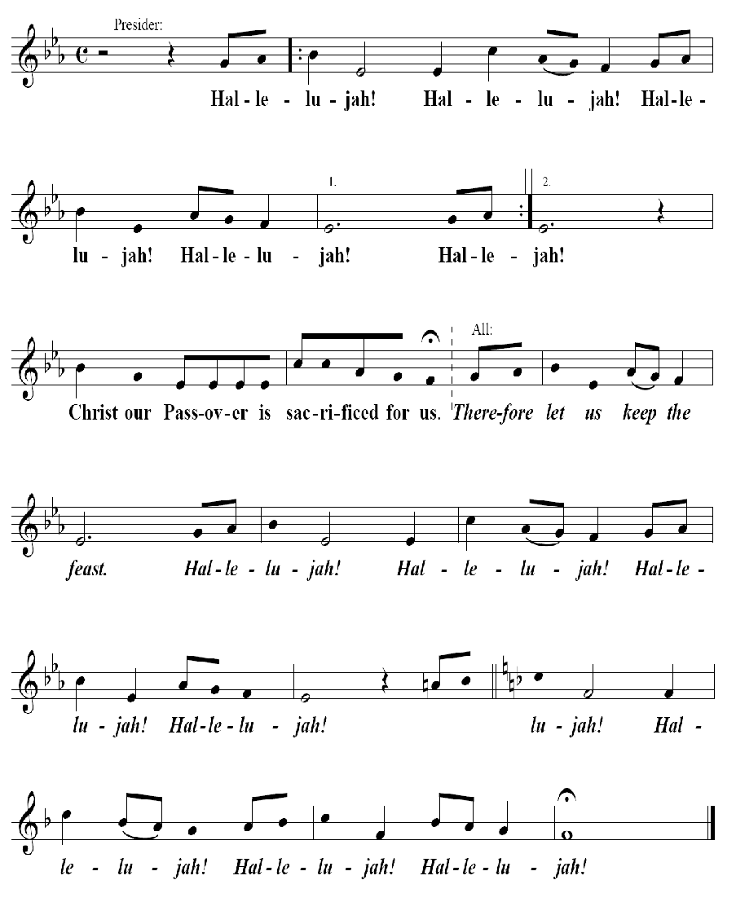

Invitation to Communion

The Presider elevates the host and the chalice together, saying:

**Presider: Behold the Lamb of God, behold Him Who takes away the sin of the world. Blessed are those called to the Supper of the Lamb.**

*People*: *Lord, I am not worthy that You should enter under my roof, but say only the word and my soul shall be healed.*

**Presider: The gifts of God for the people of God:**

**Take them in remembrance that Jesus died for you, and feed on Him in your hearts with thanksgiving.**

The Ministration of Communion

*Selection per parish or mission*

Post-Communion Prayer

**Presider: Let us pray.**

***All: Eternal God, heavenly Father, You have graciously accepted us as living members of Your Son, our Savior Jesus Christ, and You have fed us with spiritual food in the Sacrament of his Body and Blood.***

***Send us now into the world in peace and grant us strength and courage to love and serve You with gladness and singleness of heart; through Christ our Lord. Amen.***

Blessing

Miter on.

**Bishop: The Lord be with you.**

*People: And with your spirit.*

**Bishop: Our help is in the Name of the Lord.**

*People: The maker of heaven and earth.*

Deacon: Bow your heads and pray for God’s blessing.

**Presider: The peace of God, which passes all understanding, keep Your hearts and minds in the knowledge and love of God, and of His Son Jesus Christ our Lord; and the blessing of God Almighty** ✠ **the Father, the Son, and the Holy Spirit, be with you always. *Amen.***

*OR*

**Bishop: Remember the Gospel. God was in Christ Jesus reconciling the world to himself, not counting men’s sins against them. God loves you. God has forgiven you. God is not angry at you. And God will never leave you, nor forsake you. And the blessing of God Almighty, the Father** ✠ **and the Son** ✠ **and the Holy Spirit** ✠ **be with you this day and forever.**

Recessional

*Selection per parish or mission.*

Dismissal

Deacon: Go in peace glorifying the Lord by your life.

**People: *Thanks be to God. Hallelujah! Hallelujah! Amen.*** ✠