Seven Last Words of Christ

The Solemn Prayers

Veneration of the Cross

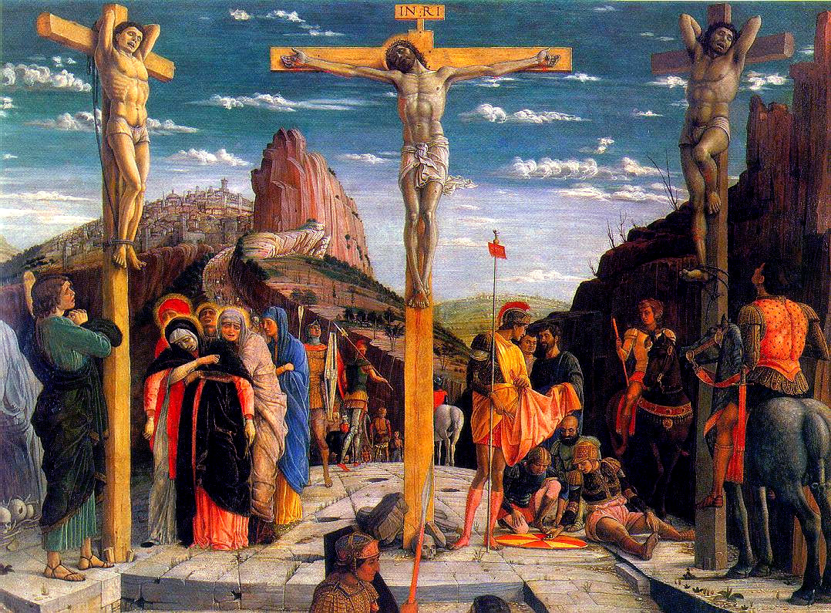Good Friday

Mass of the Pre-sanctified

April 19, 2019

Prelude

*A Musical Offering*

*From the Holy Society of King David*

**BEHOLD THE LAMB**

*George Friedrich Handel*

The Way Of The Cross

**Please stand.**

The Processional

**Presider: In the Name of the Father, and of the Son, and of the Holy Spirit.**

People: Amen.

**Presider: Let us pray.**

Face altar.

**Presider: Lord Jesus Christ, for our sake You became like the grain of wheat that falls to the earth and dies, so that it may bear much fruit. You have invited us to take up our own crosses and follow You along this path, and further said that “Those who love their life will lose it, and those who hate their life in this world will keep it for eternal life.”**

**Grant us this day, as we walk with You on the Way of the Cross, a revelation of what Your Cross meant to You, and what our Cross means to us. Grant us today the grace of contemplation, in Your Name we pray.**

***All:* *Amen.***

**Please be seated.**

The Seven Last Words Of Christ

Introduction

*A Musical Offering*

*From the Holy Society of King David*

**INTRODUCTION**

*Théodore Dubois*

First Word

*“Father, forgive them; for they know not what they do.”*

*(Luke 23:34)*

**Presider: And when they came to the place called the Skull, there they crucified Him. But Jesus was saying, “Father, forgive them; for they do not know what they are doing.”**

*A Musical Offering*

*From the Holy Society of King David*

**THE FIRST WORD**

*Théodore Dubois*

*The Extinguishing of the First Candle*

*Reflection*

Second Word

*“Verily, thou shalt be in Paradise today with me. Amen, so I tell thee.”*

*(Luke 23:43)*

**Presider: And they crucified Him with two criminals, one on the right and the other on the left. And one of the criminals who were hanged there was hurling abuse at Him, saying, “Are You not the Christ? Save Yourself and us!”**

**But the other answered, and rebuking him said, “Do you not even fear God, since you are under the same sentence of condemnation? And we indeed justly, for we are receiving what we deserve for our deeds; but this man has done nothing wrong.”**

**And he was saying, “Jesus, remember me when You come into Your Kingdom!” And He said to him, “Truly I say to you, today you shall be with Me in Paradise.”**

*A Musical Offering*

*From the Holy Society of King David*

**THE SECOND WORD**

*Théodore Dubois*

*The Extinguishing of the Second Candle*

*Reflection*

Third Word

*“See, O woman! Here behold thy Son beloved.”*

*(John 19:26)*

**Presider: But there were standing by the Cross of Jesus His mother, and His mother’s sister, Mary the wife of Clopas, and Mary Magdalene. When Jesus therefore saw His mother, and the disciple whom He loved standing nearby, He said to His mother, “Woman, behold your son!” Then He said to the disciple, “Behold your mother!”**

**And from that hour the disciple took her into his own household.**

*A Musical Offering*

*From the Holy Society of King David*

**THE THIRD WORD**

*Théodore Dubois*

*The Extinguishing of the Third Candle*

*Reflection*

Fourth Word

*“God, My Father,*

*Why hast Thou forsaken Me?”*

*(Matthew 27:46)*

**Presider: Now from the sixth hour darkness fell upon all the land until the ninth hour. And about the ninth hour Jesus cried out with a loud voice, saying, “Eli, Eli, lama Sabachthani?” that is, “My God, My God, why hast Thou forsaken Me?”**

*A Musical Offering*

*From the Holy Society of King David*

**THE FOURTH WORD**

*Théodore Dubois*

*The Extinguishing of the Fourth Candle*

*Reflection*

Fifth Word

*“I am athirst.”*

*(John 19:28)*

**Presider: After this Jesus, knowing that all things had already been accomplished, in order that the Scripture might be fulfilled, said, “I am thirsty.” A jar full of sour wine was standing there; so they put a sponge full of the sour wine upon a branch of hyssop, and brought it up to His mouth.**

*A Musical Offering*

*From the Holy Society of King David*

**THE FIFTH WORD**

*Théodore Dubois*

*The Extinguishing of the Fifth Candle*

*Reflection*

Sixth Word

*“It is finished!”*

*(John 19:30)*

**Presider: When Jesus therefore had received the sour wine, He said, “It is finished!” And He bowed His head, and gave up His spirit.**

*A Musical Offering*

*From the Holy Society of King David*

**THE SEVENTH WORD**

*Théodore Dubois*

*The Extinguishing of the Sixth Candle*

*Reflection*

Seventh Word

*“Father, into Thy hands*

*I commend My soul.”*

*(Luke 23:46*

**Presider: And darkness fell over the whole land until about the ninth hour, the sun being obscured; and Jesus, crying out with a loud voice, said, “Father, into Thy hands I commit My Spirit.”**

*A Musical Offering*

*From the Holy Society of King David*

**THE SIXTH WORD**

*Théodore Dubois*

*The Extinguishing of the Seventh Candle*

*Reflection*

Miter on.

**O SACRED HEAD NOW WOUNDED**

*1)*

*O sacred Head, now wounded,*

*with grief and shame weighed down,*

*Now scornfully surrounded with thorns, Thy only crown,*

*How art Thou pale with anguish, with sore abuse and scorn!*

*How does that visage languish which once was bright as morn!*

*2)*

*What Thou, my Lord, has suffered was all for sinners' gain;*

*Mine, mine was the transgression, but Thine the deadly pain.*

*Lo, here I fall, my Savior! 'Tis I deserve Thy place;*

*Look on me with Thy favor, vouchsafe to me Thy grace.*

*3)*

*What language shall I borrow to thank Thee, dearest friend,*

*For this Thy dying sorrow, Thy pity without end?*

*O make me Thine forever; and should I fainting be,*

*Lord, let me never, never outlive my love for Thee!*

*AMEN.*

Removal of the Christ Candle

The Deacon removes the Christ Candle.

Strepitus

The Bishop stamps his crozier three times; omitted if no bishop is present.

The Deacon replaces the Christ Candle, please stand.

Solemn Prayers

The Bishop’s unit goes up to the Altar and faces the people.

*Deacon: Dear people of God: Our heavenly Father sent His Son into the world, not to condemn the world, but that the world through Him might be saved; that all who believe in Him might be delivered from the power of sin and death, and become heirs with Him of everlasting life. We pray, therefore, for people everywhere according to their needs, devoutly kneeling.*

**Please kneel.**

*Deacon: Let us pray, dearly beloved, for the holy Church of God, that our God and Lord be pleased to give her peace, to guard her and to unite her throughout the whole world and to grant that, leading our lives in tranquility and quiet, we may glorify God the Father Almighty.*

A time of silent prayer by all.

**Presider: Almighty ever-living God, Who in Christ revealed Your glory to all the nations, watch over the works of Your mercy, that Your Church, spread throughout all the world, may persevere with steadfast faith in confessing Your Name; through Christ our Lord. *Amen.***

*Deacon: Let us pray also for Bishop Craig, Bishop Ricardo, Bishop Ariel, for all Bishops, Priests, and Deacons of the Church, and for the whole of the faithful people.*

A time of silent prayer by all.

**Presider: Almighty ever-living God, by whose Spirit the whole body of the Church is sanctified and governed, hear our humble prayer for Your ministers, that, by the gift of Your grace, all may serve You faithfully; through Christ our Lord. *Amen.***

*Deacon: Let us pray also for all catechumens, that our God and Lord may open wide the ears of their inmost hearts and unlock the gates of His mercy, that, having received forgiveness of all their sins through the waters of rebirth, they, too, may be one with Christ Jesus our Lord.*

A time of silent prayer by all.

**Presider: Almighty ever-living God, Who makes Your Church ever fruitful with new offspring, increase the faith and understanding of the catechumate, that, reborn in the font of Baptism, they may be added to the number of your adopted children; through Christ our Lord. *Amen.***

*Deacon: Let us pray also for all our brothers and sisters who believe in Christ, that our God and Lord may be pleased, as they live the truth, to gather them together and keep them in His one Church.*

A time of silent prayer by all.

**Presider: Almighty ever-living God, Who gathers what is scattered and keeps together what You have gathered, look kindly on the flock of Your Son, that those whom one Baptism has consecrated may be joined together by integrity of faith and union in the bond of charity; through Christ our Lord. *Amen.***

*Deacon: Let us pray for all nations and peoples of the earth, and also for those in public office, especially President Duterte, that our God and Lord may direct their minds and hearts according to his will for the true peace and freedom of all.*

A time of silent prayer by all.

**Presider: Almighty ever-living God, in Whose hand lies every human heart and the rights of peoples: Look with favor, we pray, on those who govern with authority over us, that throughout the whole world the prosperity of peoples, the assurance of peace, and freedom of religion may through your gift be made secure; through Christ our Lord. *Amen.***

*Deacon: Let us pray for all who suffer and are afflicted in body or in mind: for the hungry and the homeless, the destitute and the oppressed; for the sick, the wounded, and the crippled; for those in loneliness, fear, and anguish; for those who face temptation, doubt, and despair; for the sorrowful and bereaved; for prisoners and captives; and those in mortal danger; that God in His mercy will comfort and relieve them, and grant them the knowledge of His love, and stir up in us the will and patience to minister to their needs.*

A time of silent prayer by all.

**Presider: Gracious God, the comfort of all who sorrow, the strength of all who suffer: Let the cry of those in misery and need come to You, that they may find You mercy present with them in all their afflictions; and give us, we pray, the strength to serve them for the sake of Him Who suffered for us, You Son Jesus Christ our Lord. *Amen.***

*Deacon: Let us pray for all who have not received the Gospel of Christ; for those who have never heard the word of salvation; for those who have lost their faith; for those hardened by sin or indifference; for the contemptuous and scornful; for those who are enemies of the cross of Christ and persecutors of His disciples; for those who in the Name of Christ have persecuted others; that God will open their hearts to the truth, and lead them to faith and obedience.*

A time of silent prayer by all.

Presider: Merciful God, creator of all the peoples of the earth and lover of souls: Have compassion on all who do not know You as You are revealed in Your Son Jesus Christ; let Your Gospel be preached with grace and power to those who have not heard it; turn the hearts of those who resist it; and bring home to Your fold those who have gone astray; that there may be one flock under one Shepherd, Jesus Christ our Lord. Amen.

*Deacon: Let us commit ourselves to God, and pray for the grace of a holy life, that, with all who have departed this world and have died in the peace of Christ, and with those whose faith is known to God alone, we may be accounted worthy to enter into the fullness of the joy of our Lord, and receive the crown of life in the day of resurrection.*

A time of silent prayer by all.

**Presider: O God of unchangeable power and eternal light: Look favorably upon Your whole Church, that wonderful and sacred mystery; and by the tranquil operation of Your providence, carry out the work of man's salvation; let the whole world see and know that things which were cast down are being raised up, and things which had grown old are being made new, and that all things are being brought unto the perfection of Him through Whom all things were made, Your Son our Lord Jesus Christ; Who lives and reigns with You in the unity of the Holy Spirit, one God, forever and ever.**

*All: Amen*.

Veneration of the Cross

**Please stand.**

All stand. The Deacon goes to the rear door of the nave, outside of which is waiting for him the veiled Processional Cross and two torches held by assisting ministers. Accompanied by the torches he brings the cross into the nave. Near the door he raises the Cross and stops to say or chant:

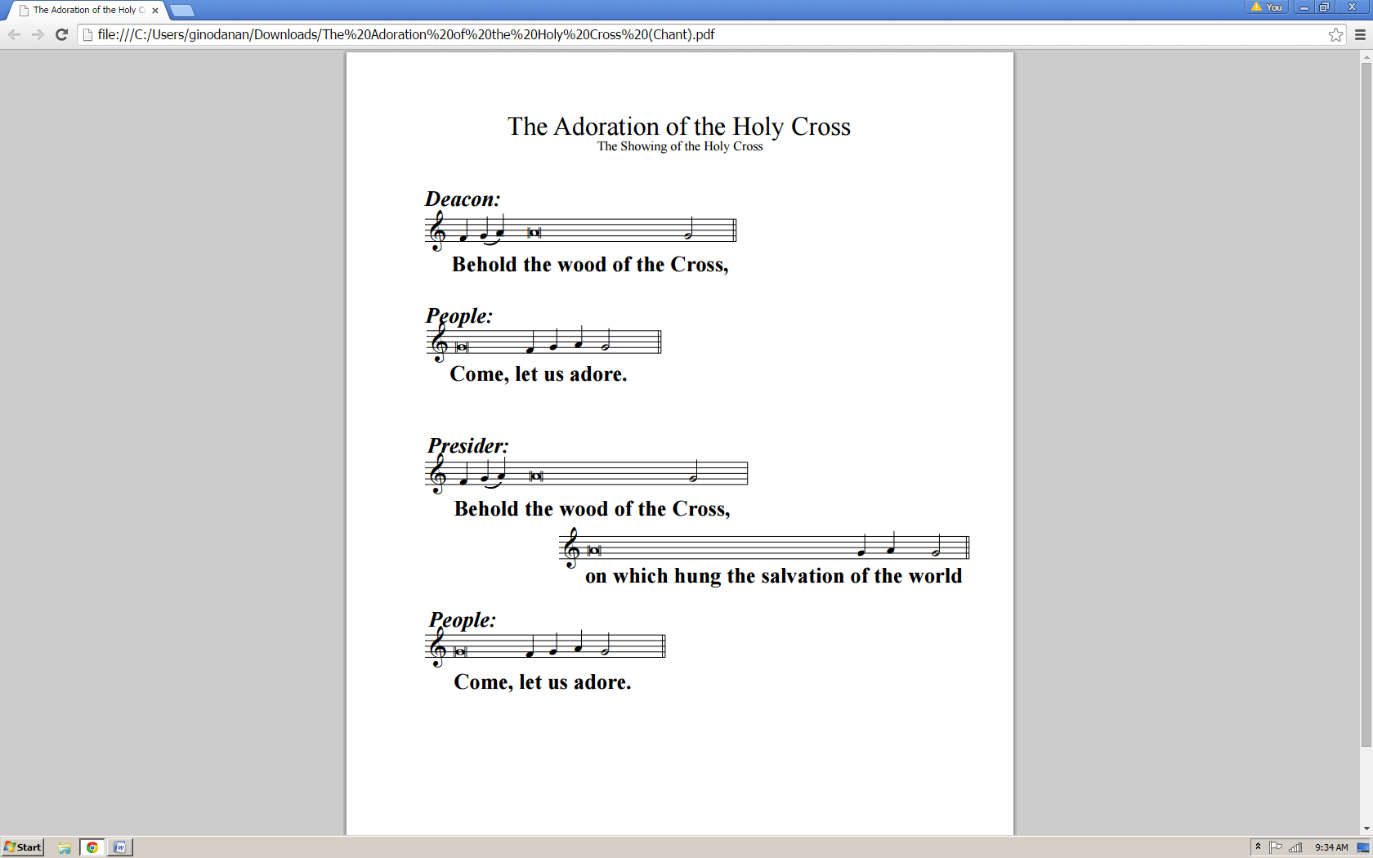

This action is repeated at the center of the Nave, then just before the Sanctuary.

Then the Cross is handed to the Presider, standing at the front of the Chancel, who lifts it and says or chants:

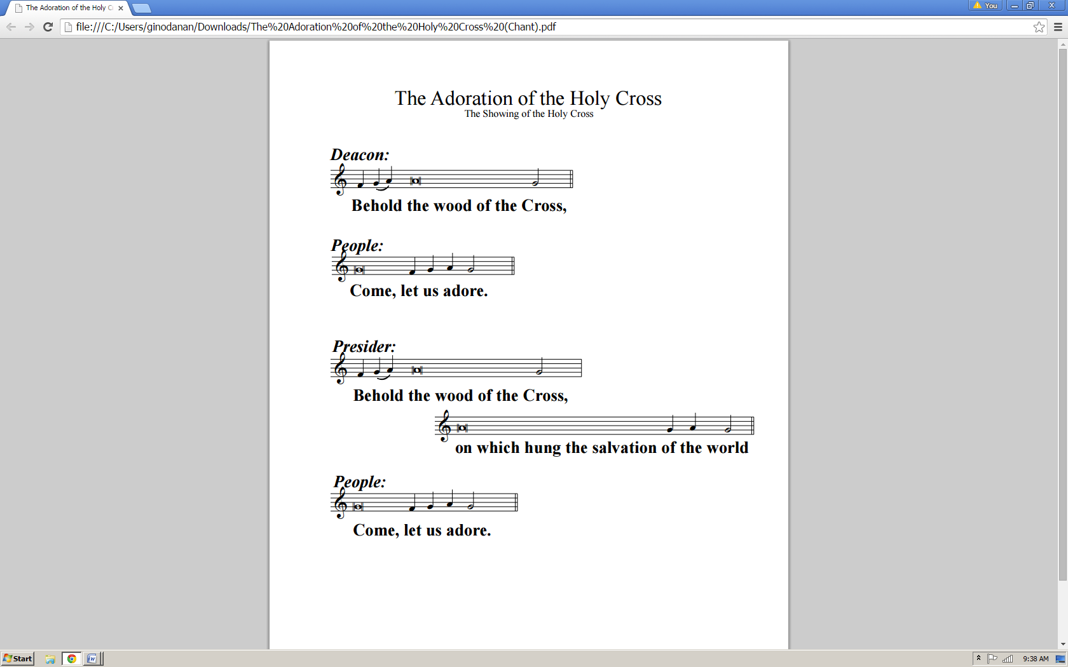

The Cross is handed back to the Deacon, who places it in its stand in the center of the Sanctuary. The Torch bearers do the same with their torches. Then they return to their places. The Presider addresses the people.

**Presider: My brothers and sisters, by our common baptism we have embraced the Cross of Christ, thus dying with Him. We have also been caught up in His resurrection, thus rising with Him. Let us now venerate the Cross of our Savior.**

**Please kneel.**

All kneel and face the Cross.

**Presider: We venerate the Cross, O Lord; and praise and glorify Your holy Resurrection: for by virtue of the Cross joy has come to the whole world.**

**Presider: God be merciful unto us and bless us.**

People: And show us the light of His countenance, and be merciful unto us.

**Presider: We venerate the Cross, O Lord; and praise and glorify Your holy Resurrection: for by virtue of the Cross joy has come to the whole world.**

**Presider: Let us pray together:**

***All: Lord God and loving Father, grant me a deeper insight into the meaning of the Cross of Your Son, Jesus Christ. I contemplate the Cross, as did Mary, the Mother of the Lord, John the faithful witness, Stephen the first Martyr and so many others after them.***

***May I see the glory of Your Son shining from the Cross; the glory of a love that is faithful to the end. Grant me a share in the experience of the first disciples, the saints, mystics and martyrs who forgave their enemies and offered their lives for their faith.***

***Lord, may I have the courage to face the Cross and never accept suffering for its own sake nor give up on life and its joys. Help me to accept the Cross if it means abandoning myself to You.***

***Help me to recognize that I am in Your hands, even when everything seems to indicate the contrary. Help me to accept the Cross, if it is the price of the battle against injustice, violence, hatred and the abuse of power.***

***Help me to risk the Cross, to suffer and even to die for the sake of making the world more human. Help me to accept the Cross if it means announcing You, the God of Life, to those for whom life has lost all of its meaning.***

***All: Today, I accept the Christian way, to be Your disciple and to bring hope to those who despair through Jesus Christ, our Lord and Brother, Who forgave His tormentors and revealed Himself to be the Messiah, Who lives and reigns with You in the unity of the Holy Spirit, one God, forever and ever. Amen.***

Bishop’s unit remains; people remain kneeling

Confession of Sin

Face people, Miter off.

**Presider: Let us confess our sins against God and our neighbor.**

***All: Almighty and Most Merciful Father, I have erred and strayed from Your ways like a lost sheep. I have followed too much the devices and desires of my own heart; I have offended against Your holy laws. I have left undone those things which I ought to have done, and I have done those things which I ought not to have done.***

***But Lord, have mercy upon me. Spare those who confess their faults, restore those who are penitent, according to Your promises declared unto mankind in Christ Jesus our Lord; and empower me, O Most Merciful Father, to live a godly, righteous, and sober life, to the glory of Your holy Name. Amen.***

Absolution

Still kneeling

**Presider: Almighty God have mercy on you, forgive you all your sins + through our Lord Jesus Christ, strengthen you in all goodness, and by the power of the Holy Spirit keep you in eternal life.**

*People: Amen.*

Mass of the Presanctified

All stand, all ministers reverence the Altar and go to their places to prepare for Communion. Bishop dons his chasuble.

Hymn

**TAKE MY LIFE AND LET IT BE**

*1)*

*Take my life and let it be, consecrated Lord, to Thee;*

*Take my hands and let them move, at the impulse of Thy love,*

*At the impulse of Thy love.*

*2)*

*Take my feet and let them be, swift and beautiful for Thee;*

*Take my voice and let me sing, always, only, for my King,*

*Always, only, for my King.*

*3)*

*Take my silver and my gold, not a mite would I withhold,*

*Take my moments and my days, let them flow in ceaseless praise,*

*Let them flow in ceaseless praise.*

*4)*

*Take my will and make it Thine, it shall be no longer mine,*

*Take my heart, it is Thine own. it shall be Thy royal throne,*

*It shall be Thy royal throne.*

The Lord’s Prayer

The Lord’s Prayer is spoken in unison by the Presider and the People.

**Presider: As our Savior Christ taught us, we are bold to pray:**

***All: Our Father, Who art in Heaven, hallowed be Thy Name. Thy kingdom come; Thy will be done on earth as it is in heaven.***

Give us this day our daily bread. And forgive us our trespasses, as we forgive those who trespass against us. And lead us not into temptation. But deliver us from evil.

For Thine is the kingdom, and the power, and the glory; forever and ever. Amen. ✠

Lamb of God (*Agnus Dei*)

The Lamb of God (*Agnus Dei*) is spoken in unison by the Presider and the People.

**Lamb of God, You take away the sins of the world:**

***have mercy on us.***

**Lamb of God, You take away the sins of the world:**

***have mercy on us.***

**Lamb of God, You take away the sins of the world:**

***grant us peace.***

Invitation to Communion

The Presider elevates the host and the chalice together, saying:

**Presider: Behold the Lamb of God, behold Him Who takes away the sins of the world. Blessed are those called to the Supper of the Lamb.**

*People*: *Lord, I am not worthy that You should enter under my roof, but say only the word and my soul shall be healed.*

**Presider: The gifts of God for the people of God:**

**Take them in remembrance that Jesus died for you, and feed on Him in your hearts with thanksgiving.**

The Ministration of Communion

**WE RECEIVED THE LIVING GOD**

*Chorus)*

*We received the Living God,*

*and our hearts are full of joy.*

*We received the Living God,*

*and our hearts are full of joy.*

*1)*

*He has said: I AM THE BREAD,*

*kneaded long to give you life;*

*you who will partake of Me,*

*need not ever fear or die.*

*2)*

*He has said: I AM THE WAY,*

*and my Father longs for you;*

*so I come to bring you hope,*

*to be one with Him anew.*

*3)*

*He has said: I AM THE TRUTH.*

*If you follow close to Me,*

*you will know Me in your heart,*

*and My Word shall make you free.*

*4)*

*He has said: I AM THE LIFE,*

*far from Whom nothing can grow,*

*but receive this Living Bread,*

*and My Spirit you shall know.*

**HE WAS WOUNDED FOR OUR TRANSGRESSIONS**

*He was wounded for our transgressions,*

*He bore our sins in His body on the tree;*

*For our guilt He gave us peace,*

*From our bondage gave release,*

*And with His stripes,*

*and with His stripes,*

*And with His stripes our souls are healed.*

*He was numbered among transgressors,*

*We did esteem Him forsaken by His God;*

*As our sacrifice He died,*

*That the law be satisfied,*

*And all our sin,*

*and all our sin,*

*And all our sin was laid on Him.*

*We had wandered, we all had wandered*

*Far from the fold of "the Shepherd of the sheep";*

*But He sought us where we were,*

*On the mountains bleak and bare,*

*And bro't us home,*

*and bro't us home,*

*And bro't us safely home to God.*

*Who can number His generation?*

*Who shall declare all the triumphs of His Cross?*

*Millions, dead, now live again,*

*Myriads follow in His train!*

*Victorious Lord,*

*victorious Lord,*

*Victorious Lord and coming King!*

Post-Communion Prayer

**Presider: Let us pray.**

***All: Almighty and everliving God, we thank You for feeding us with the spiritual food of the most precious Body and Blood of Your Son, our Savior Jesus Christ; and for assuring us in these holy mysteries that we are living members of the Body of Your Son, and heirs of Your eternal kingdom.***

***And now, Father, send us out to do the work You have given us to do, to love and serve You as faithful witnesses of Christ our Lord.***

***To him, to You, and to the Holy Spirit, be honor and glory, now and forever. Amen.***

The people leave in silence.