ORDER

OF THE

HOLY MASS

Season of Lent

“Proclamation of

Profitable

Self-denial”

First Sunday in Lent

March 1, 2020

Processional

**Please stand**

**BEHOLD THE LAMB**

***(Words and Music By : Dottie Rambo)***

***(C 1979 John T. Benson Publishing Company)***

*Chorus)*

*Behold the Lamb, behold the Lamb!*

*Slain from the foundation of the world.*

*For sinners crucified, O holy sacrifice,*

*Behold the Lamb of God, behold the Lamb!*

*Verse)*

*Crown Him, crown Him, worthy is the Lamb!*

*Praise Him, praise Him, heaven and earth resound.*

Acclamation

*The Ministers face the Presider, while the Presider faces the people and proclaims:*

**Presider: Bless the Lord Who forgives all our sins;**

*People: His mercy endures forever.* ***Amen.***

Collect for Purity

**Presider: Let us pray.**

*Clergy face the Altar. Miter off.*

**Almighty God, to You all hearts are open,**

**all desires known, and from You no secrets are hid.**

**Cleanse the thoughts of our hearts ✠**

**by the inspiration of Your Holy Spirit,**

**that we may perfectly love You**

**and worthily magnify Your holy Name;**

**through Christ our Lord.**

***All: Amen.***

The Great Litany

**Presider: O God the Father, Creator of heaven and earth,**

*People: Have mercy upon us.*

**Presider: O God the Son, Redeemer of the world,**

*People: Have mercy upon us.*

**Presider: O God the Holy Ghost, Sanctifier of the faithful,**

*People: Have mercy upon us.*

**Presider: O holy, blessed, and glorious Trinity, one God,**

*People: Have mercy upon us.*

**Presider: Remember not, Lord Christ, our offenses, nor the offenses of our forefathers; neither reward us according to our sins. Spare us, good Lord, spare thy people, whom Thou hast redeemed with Thy most precious blood, and by Thy mercy preserve us forever.**

*People: Spare us, good Lord.*

**Presider: From all evil and wickedness; from sin; from the crafts and assaults of the devil; and from everlasting damnation,**

*People: Good Lord, deliver us.*

**Presider: From all blindness of heart; from pride, vainglory, and hypocrisy; from envy, hatred, and malice; and from all want of charity,**

*People: Good Lord, deliver us.*

**Presider: From all inordinate and sinful affections; and from all the deceits of the world, the flesh, and the devil,**

*People: Good Lord, deliver us.*

**Presider: From all false doctrine, heresy, and schism; from hardness of heart, and contempt of Thy Word and commandment,**

*People: Good Lord, deliver us.*

**Presider: From lightning and tempest; from earthquake, volcano, fire, and flood; from plague, pestilence, and famine,**

*People: Good Lord, deliver us.*

**Presider: From all oppression, conspiracy, and rebellion; from violence, battle, and murder; and from dying suddenly and unprepared,**

*People: Good Lord, deliver us.*

**Presider: By the mystery of Thy holy Incarnation; by Thy holy Nativity and submission to the Law; by Thy Baptism, Fasting, and Temptation,**

*People: Good Lord, deliver us.*

**Presider: By Thine Agony and Bloody Sweat; by Thy Cross and Passion; by Thy precious Death and Burial; by Thy glorious Resurrection and Ascension; and by the Coming of the Holy Ghost,**

*People: Good Lord, deliver us.*

**Presider: In all time of our tribulation; in all time of our prosperity; in the hour of death, and in the day of judgment,**

*People: Good Lord, deliver us.*

**Presider: We sinners do beseech Thee to hear us, O Lord God; and that it may please Thee to rule and govern Thy holy catholic Church in the right way,**

*People: We beseech Thee to hear us, good Lord.*

**Presider: That it may please Thee to illumine all bishops, priests, and deacons, especially Craig our Patriarch, Ricardo our Primate, and Ariel our Bishop, with true knowledge and understanding of Thy Word; and that both by their preaching and living, they may set it forth, and show it accordingly,**

*People: We beseech Thee to hear us, good Lord.*

**Presider: That it may please Thee to bless and keep all thy people,**

*People: We beseech Thee to hear us, good Lord.*

**Presider: That it may please Thee to send forth laborers into Thy harvest, and to draw all mankind into Thy kingdom,**

*People: We beseech Thee to hear us, good Lord.*

**Presider: That it may please Thee to give to all people increase of grace to hear and receive Thy Word, and to bring forth the fruits of the Spirit,**

*People: We beseech Thee to hear us, good Lord.*

**Presider: That it may please thee to bring into the way of truth all such as have erred, and are deceived,**

*People: We beseech Thee to hear us, good Lord.*

**Presider: That it may please Thee to give us a heart to love and fear Thee, and diligently to live after thy commandments,**

*People: We beseech Thee to hear us, good Lord.*

**Presider: That it may please Thee so to rule the hearts of Thy servants, President Duterte, and all others in authority, that they may do justice, and love mercy, and walk in the ways of truth,**

*People: We beseech Thee to hear us, good Lord.*

**Presider: That it may please Thee to make wars to cease in all the world; to give to all nations unity, peace, and concord; and to bestow freedom upon all peoples,**

*People: We beseech Thee to hear us, good Lord.*

**Presider: That it may please Thee to show Thy pity upon all prisoners and captives, the homeless and the hungry, and all who are desolate and oppressed,**

*People: We beseech Thee to hear us, good Lord.*

**Presider: That it may please Thee to give and preserve to our use the bountiful fruits of the earth, so that in due time all may enjoy them,**

*People: We beseech Thee to hear us, good Lord.*

**Presider: That It may please Thee to inspire us, in our several callings, to do the work which Thou givest us to do with singleness of heart as Thy servants, and for the common good,**

*People: We beseech Thee to hear us, good Lord.*

**Presider: That it may please Thee to preserve all who are in danger by reason of their labor or their travel,**

*People: We beseech Thee to hear us, good Lord.*

**Presider: That it may please Thee to preserve, and provide for, all women in childbirth, young children and orphans, the widowed, and all whose homes are broken or torn by strife,**

*People: We beseech Thee to hear us, good Lord.*

**Presider: That it may please Thee to visit the lonely; to strengthen all who suffer in mind, body, and spirit; and to comfort with Thy presence those who are failing and infirm,**

*People: We beseech Thee to hear us, good Lord.*

**Presider: That it may please Thee to support, help, and comfort all who are in danger, necessity, and tribulation,**

*People: We beseech Thee to hear us, good Lord.*

**Presider: That it may please Thee to have mercy upon all men,**

*People: We beseech Thee to hear us, good Lord.*

**Presider: That it may please Thee to give us true repentance; to forgive us all our sins, negligences, and ignorances; and to endue us with the grace of Thy Holy Spirit to amend our lives according to Thy holy Word,**

*People: We beseech Thee to hear us, good Lord.*

**Presider: That it may please Thee to forgive our enemies, persecutors, and slanderers, and to turn their hearts,**

*People: We beseech Thee to hear us, good Lord.*

**Presider: That it may please Thee to strengthen such as do stand; to comfort and help the weak-hearted; to raise up those who fall; and finally to beat down satan under our feet,**

*People: We beseech Thee to hear us, good Lord.*

**Presider: That it may please Thee to grant to all the faithful departed eternal life and peace,**

*People: We beseech Thee to hear us, good Lord.*

**Presider: That it may please Thee to grant that, in the fellowship of the Charismatic Episcopal Church and all the saints, we may attain to Thy heavenly kingdom,**

*People: We beseech Thee to hear us, good Lord.*

**Presider: Son of God, we beseech Thee to hear us.**

*People: Son of God, we beseech Thee to hear us.*

**Presider: O Lamb of God, Who takest away the sin of the world,**

*People: Have mercy upon us.*

**Presider: O Lamb of God, Who takest away the sin of the world,**

*People: Have mercy upon us.*

**Presider: O Lamb of God, Who takest away the sin of the world,**

*People: Grant us Thy peace.*

**Presider: O Christ, hear us.**

*People: O Christ, hear us.*

**Presider: Lord, have mercy upon us.**

*People: Christ, have mercy upon us.*

**Presider: Lord, have mercy upon us.**

Lent Hymn *(in place of the Gloria)*

**ETERNAL LORD OF LOVE**

***(Thomas H. Cain; c. Public domain)***

*1) Eternal Lord of love behold Your Church,*

*Walking once more the pilgrim way of Lent;*

*Led by Your cloud by day, by night Your fire:*

*Moved by Your love and toward Your presence bent:*

*Far off yet here - the goal of all desire.*

*2) So daily dying to the way of self,*

*So daily living to Your way of love.*

*We walk the road, Lord Jesus, that You trod;*

*Knowing ourselves baptized into Your death:*

*So, we are dead and live with You in God.*

*3) If dead in You, so in You we arise,*

*You the firstborn of all the faithful dead;*

*And as through stony ground the green shoots break;*

*Glorious in springtime dress of leaf and flower.*

*So, in the Father's glory shall we wake.*

Collect of the Day Proper 1st Sunday CEC

*Presider faces the people.*

**Presider: The Lord be with you.**

*People: And with your spirit.*

**Presider: Let us pray.**

*Presider and Ministers face the Altar.*

*The Collect of the Day is taken from the Proper for that Sunday or feast day.*

**Presider: Almighty God, Whose blessed Son was led by the Spirit to be tempted by satan, Come quickly to help us who are assaulted by many temptations; and, as You know the weaknesses of each of us, let each one find You mighty to save; through Jesus Christ Your Son our Lord, Who lives and reigns with You and the Holy Spirit, one God, now and forever.**

***All: Amen.***

*Presider goes to the back of the Altar, kisses it, and goes to his chair.*

Liturgy of the Word

**Please be seated**

First Proclamation

Proclaimer: A Proclamation of the Word of God from the book of Genesis, Chapters Two and Three

Genesis 2: 15-17; 3: 1-7

Proclaimer: The Word of the Lord.

***People: Thanks be to God!***

Responsorial Psalm:

Psalm 32

Proclaimer: Please stand for the Responsorial Psalm, which today is Psalm Thirty-Two.

*All stand and the Proclaimer leads the people in the Responsorial Psalm followed by the Gloria Patri.*

Proclaimer: How blessed is he whose transgression is forgiven, whose sin is covered!

*People: How blessed is the man to whom the Lord does not impute iniquity, and in whose spirit there is no deceit!*

Proclaimer: When I kept silent about my sin, my body wasted away through my groaning all day long.

*People: For day and night Your hand was heavy upon me; my vitality was drained away as with the fever heat of summer.*

Proclaimer: I acknowledged my sin to You, and my iniquity I did not hide; I said, “I will confess my transgressions to the Lord”; and You forgave the guilt of my sin.

*People: Therefore, let everyone who is godly pray to You in a time when You may be found; surely in a flood of great waters they will not reach him.*

Proclaimer: You are my hiding place; You preserve me from trouble; You surround me with songs of deliverance.

*People: I will instruct you and teach you in the way which you should go; I will counsel you with My eye upon you.*

Proclaimer: Do not be as the horse or as the mule which have no understanding, whose trappings include bit and bridle to hold them in check, otherwise they will not come near to you.

*People: Many are the sorrows of the wicked, but he who trusts in the Lord, lovingkindness shall surround him.*

Proclaimer: Be glad in the Lord and rejoice, you righteous ones; and shout for joy, all you who are upright in heart.

*Gloria Patri* (BCP, Rite II)

*The Gloria Patri may be spoken or sung in unison. The Proclaimer and Altar Ministers remain in their places, face the Altar, and bow.*

***All: Glory to the Father, and to the Son, and to the Holy Spirit:* ✠**

***As it was in the beginning, is now, and will be forever. Amen.***

A Lenten Hymn may be sung here.

**SONG SPECIAL**

**KYRIE**

*Michael W. Smith/Claire Cloninger)*

*(C 1989 Word Music /ASCAP/O'Ryan Music)*

*1)*

*Unworthy of Your grace, I come before Your face*

*Oh, Thou sacrificial Lamb, Great Son of the Great I AM!*

*I bring every thing I am to You.*

*Chorus 1)*

*Kyrie (Kyrie eleison)*

*Christe (Christe eleison)*

*Kyrie, look with love now upon Your own*

*And have mercy, mercy, mercy!*

*2)*

*You bore my sin and shame that I might trust Your Name.*

*You were and You are to be Great God of eternity.*

*I bring every sin in me to You.*

*Chorus 2)*

*Kyrie (Kyrie eleison)*

*Christe (Christe eleison)*

*Kyrie, look with love now upon your own.*

*Kyrie, Kyrie eleison (eleison)!*

**Please be seated**

Second Proclamation

Proclaimer: A Proclamation of the Word of God from the letter to the Romans, Chapter Five.

Romans 5: 12-17

*The proclaimer reads the second appointed lesson of the day.*

Proclaimer: The Word of the Lord.

***People: Thanks be to God!***

**Please stand.**

Gradual Verse

Proclaimer: If Your Law had not been my delight, then I would have perished in my affliction; this is my comfort in my affliction, that Your Word has revived me.

*Miter On. Bless the Gospel Proclaimer.*

Gradual Hymn

**ANCIENT WORDS**

***(Lynn Deshazo; c. Hosanna! Music)***

*1)*

*Holy words long preserved for our walk in this world,*

*They resound with God’s own heart.*

*O, let the ancient words impart.*

*Words of life, words of hope, give us strength, help us cope.*

*In this world where’er we roam,*

*Ancient words will guide us home.*

*Chorus)*

*Ancient words, ever true,*

*changing me and changing you;*

*We have come with open hearts,*

*O, let the ancient words impart.*

*2)*

*Holy words of our faith handed down to this age,*

*Came to us through sacrifice.*

*O, heed the faithful words of Christ.*

*Holy words long preserved for our walk in this world,*

*They resound with God’s own heart.*

*O, let the ancient words impart.*

Gospel Acclamation

*Miter Off.*

Deacon: The Lord be with you.

*People: And with your spirit.*

Deacon: May the Lord be on our **✠** minds, on our **✠** lips, and on our **✠** hearts as we hear **✠** His Holy Gospel.

The Holy Gospel of our Lord Jesus Christ according to Saint Matthew, Chapter Four.

*People: Glory to You, Lord Christ!*

Gospel Proclamation

*The appointed Gospel is read by a Deacon.*

Matthew 4: 1-11

*Deacon: The Gospel of the Lord.*

***People: Praise to You, Lord Christ!***

*All sit.*

Homily

**Please stand**

Nicene Creed

***All: We believe in one God, the Father Almighty, Maker of Heaven and earth, and of all things: visible and invisible.***

***And in one Lord, Jesus Christ, the only begotten Son of God, begotten of His Father before all worlds;***

***God of God, Light of Light, very God of very God***

***begotten, not made, being of one substance with the Father;***

***by Whom all things were made;***

***Who for us men and for our salvation came down from Heaven;***

***and was incarnate by the Holy Spirit and the Virgin Mary, and was made man;***

***And was crucified also for us under Pontius Pilate;***

***He suffered death and was buried, and rose again on the third day, in accordance with the Scriptures;***

***and ascended into Heaven, and is seated on the right hand of the Father;***

***and He shall come again, with glory, to judge the living and the dead;***

***Whose Kingdom shall have no end.***

***And we believe in the Holy Spirit the Lord, and Giver of Life, Who proceeds from the Father;***

***Who with the Father and the Son together is worshiped and glorified;***

***Who has spoken through the prophets.***

***And we believe one holy catholic and apostolic Church;***

***We acknowledge one baptism for the remission of sins;***

***and we look for the resurrection of the dead, and the life of the world to come. Amen.* ✠**

Peace

**Presider: The peace of the Lord be always with you.**

*People: And with your spirit.*

**Presider: Let us offer one another a sign of God’s peace.**

Offertory

*Presider gives the Offering Exhortation.*

Worship in Psalms,

Hymns,

and Spiritual Songs:

The Sacrifice

of Praise

The Offertory:

The Sacrifice

of Ourselves

**WE CHOOSE THE FEAR OF THE LORD**

*1)*

*We choose the fear of the Lord,*

*We choose the fear of the Lord*

*For the fear of the Lord is to hate all evil,*

*We choose the fear of the Lord,*

*We choose the fear of the Lord.*

*2)*

*We choose the way of the Lord,*

*We choose the way of the Lord*

*For the way of the Lord is the way of wisdom,*

*We choose the way of the Lord,*

*We choose the way of the Lord.*

*3)*

*We choose the Word of the Lord,*

*We choose the Word of the Lord*

*For the Word of the Lord shall endure forever,*

*We choose the Word of the Lord,*

*We choose the Word of the Lord.*

*Chorus)*

*He who delights in the Word of the Lord*

*Shall be blessed in all of his ways,*

*For the friendship of God*

*Is with those who fear Him.*

*So we choose the fear of the Lord,*

*We choose the fear of the Lord.*

*END) We choose the fear of the Lord.*

**BLESSED BE YOUR NAME (Redman)**

*1) Blessed be Your Name in the land that is plentiful,*

*Where the streams of abundance flow,*

*Blessed be Your Name.*

*Blessed be Your Name when I'm found in the desert place,*

*Though I walk in the wilderness, blessed be Your Name*

*Every blessing You pour out I'll turn back to praise.*

*When the darkness closes in, Lord, still I will say,*

*Chorus)*

*Blessed be the Name of the Lord,*

*Blessed be Your Name.*

*Blessed be the Name of the Lord,*

*Blessed be Your glorious Name.*

*2) Blessed be Your Name*

*When the sun's shining down on me,*

*When the world's all as it should be blessed be Your Name.*

*Blessed be Your Name on the road marked with suffering,*

*Though there's pain in the offering, blessed be Your Name.*

*Every blessing You pour out I'll turn back to praise.*

*When the darkness closes in, Lord, still I will say,*

*BRIDGE) You give and take away, You give and take away.*

*My heart will choose to say, "Lord, blessed be Your Name."*

**WE SING YOUR MERCIES**

*Chorus)*

*We sing Your mercies, we sing Your endless praises,*

*We sing Your everlasting love.*

*We sing Your mercies, we sing Your endless praises,*

*Sov’reign One Who died, Sov’reign One Who died for us.*

*1) Should He Who made the stars be hung upon a tree?*

*And should the hands that healed be driven through for me?*

*Should He Who gave us bread be made to swallow gall?*

*Should He Who gave us breath and life*

*be slaughtered for us all.*

*2) Should He Who is the light be cast into the dark?*

*And should the Lord of love*

*be pierced through His own heart?*

*Should He Who called us friends be deserted by us all?*

*Should He Who lived a sinless life be punished for our fall?*

**ABOVE ALL**

***(Lenny LeBlanc & Paul Baloche;***

***c. LenSongs Publishing / Hosanna Music)***

*Verse)*

*Above all powers, above all kings,*

*Above all nature and all created things.*

*Above all wisdom and all the ways of man,*

*You were here before the world began.*

*Above all kingdoms, above all thrones,*

*Above all wonders the world has ever known.*

*Above all wealth, and treasures of the earth,*

*There’s no way to measure what You’re worth.*

*Chorus)*

*Crucified, laid behind the stone.*

*You lived to die, rejected and alone.*

*Like a rose trampled on the ground,*

*You took the fall and thought of me above all.*

*CODA)*

*Like a rose trampled on the ground,*

*You took the fall and thought of me above all.*

**THE STEADFAST LOVE OF THE LORD**

**(Unknown; c. Unknown)**

*Verse)*

*The steadfast love of the Lord never ceases,*

*His mercies never come to an end;*

*Chorus)*

*They are new every morning, new every morning;*

*Great is Thy faithfulness, O Lord, great is Thy faithfulness.*

**Pag-ibig Mo ay Hindi Magmamaliw**

**(The Steadfast Love of the Lord)**

*Pag-ibig Mo ay hindi magmamaliw.*

*Ang awa mo ay walang kapantay.*

*Ito’y laging sariwa, bawat umaga*

*Katapatan Mo ay dakila.*

*Katapatan Mo’y dakila.*

The Lesser Doxology may be sung in a high mass, during which time the Presider censes the gifts.

After the Altar and Gifts have been censed by the Presider, the Deacon censes the Ministers, then all of the people.

Then Presider censes the front of the Altar and the Ministers again.

Lesser Doxology

*(Traditional)*

*(Words and Music By: Thomas Ken)*

*(Attributed To Louis Bourgeois)*

*Praise God from Whom all blessings flow,*

*Praise Him all creatures here below;*

*Praise Him above, ye heavenly Host:*

*Praise Father, Son and Holy Ghost!*

*AMEN!*

Preparation of the Gifts

*Standing behind the Altar, the Presider takes the paten with the bread or a large host, and, holding it slightly raised above the altar, says:*

**Presider: Blessed are You Lord, God of all creation. For through Your goodness we have received the bread we offer You: fruit of the earth and work of human hands, it will become the Body of Christ.**

*People: Blessed be God forever.*

*While pouring a small amount of water into the chalice and flagon, the Presider says quietly:*

**Presider: By the mystery of this water and wine may we come to share in the divinity of Christ, who humbled Himself to share in our humanity.**

*Then the Presider takes the chalice and, holding it slightly raised above the altar, says:*

**Presider: Blessed are You Lord, God of all creation, for through Your goodness we have received the wine we offer You, fruit of the vine and work of human hands; it will become the Blood of Christ.**

*People: Blessed be God forever.*

*Then the Presider takes an offering basket or bag, and while holding it slightly raised above the altar, says:*

**Presider: Blessed are You Lord, God of all creation, for through Your goodness we bring these tithes and offerings before You. They will be used in Your church for the work You have set before us and the furthering of Your kingdom.**

*Presider places the offering below the altar, then washes his hands, quietly saying:*

**Presider: Wash me, O Lord, from my iniquity and cleanse me from my sin.**

Exhortation To Pray (*Orate fratres*)

*The Presider returns to the center of the altar, faces the people, and says:*

**Presider: Pray, brothers and sisters, that our sacrifice may be acceptable to God, the Almighty Father.**

*People: May the Lord accept the sacrifice at your hands for the praise and glory of His name, for our good and the good of all His holy Church.*

***All: Amen.***

Great Thanksgiving

**Presider: The Lord be with you.**

*People: And with your spirit.*

**Presider: Lift up your hearts.**

*People: We lift them up to the Lord.*

**Presider: Let us give thanks to the Lord our God.**

*People: It is right to give Him thanks and praise.*

Preface Lent CEC

*The priest continues the preface with hands extended:*

**Presider: It is truly right and just, our duty and our salvation, always and everywhere to give You thanks, Lord, holy Father, almighty and eternal God, through Christ our Lord.**

**For by Your gracious gift each year Your faithful await the sacred paschal feasts with the joy of minds made pure, so that, more eagerly intent on prayer and on the works of charity, and participating in the mysteries by which they have been reborn, they may be led to the fullness of grace that You bestow on Your sons and daughters.**

**And so, with angels and archangels, with thrones and dominions, and with all the hosts and powers of heaven, we sing the hymn of Your glory, as without end we acclaim:**

Sanctus Benedictus

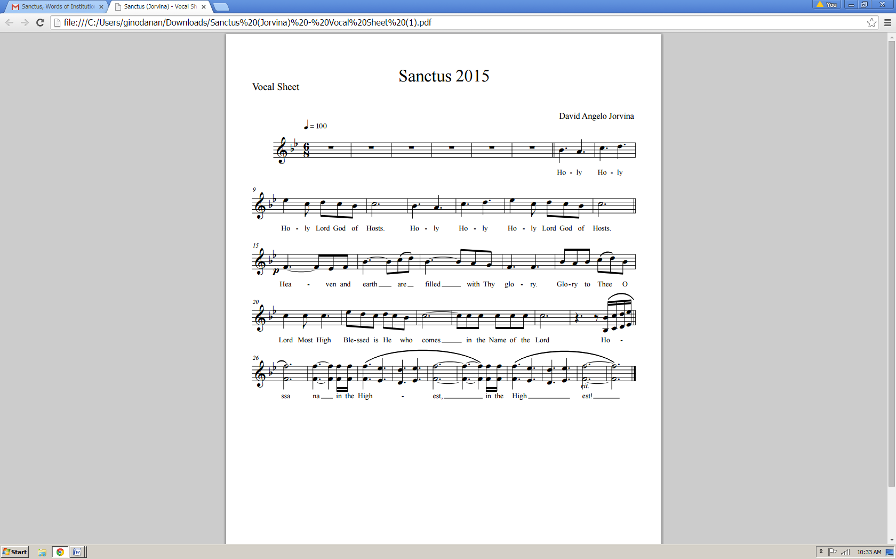

Eucharistic Prayer IV CEC

**Presider: Holy and gracious Father, in Your infinite love You made us for Yourself, and when we had fallen into sin and become subject to evil and death, You, in Your mercy sent Jesus Christ, Your only and eternal Son, to share our human nature, to live and die as one of us, to reconcile us to You, the God and Father of all.**

**He stretched out his arms on the cross and offered himself, in obedience to Your will, a perfect sacrifice for the whole world.**

Epiclesis

**Please kneel**

*The Presider joins his hands, then, holding them outstretched over the offerings, says:*

**Presider: And so, Father, we pray that, in Your goodness and mercy, Your Holy Spirit may descend upon us and upon these gifts, sanctifying them and showing them to be holy gifts for Your holy people, the bread of life and the cup of salvation,**

*The Presider joins his hands, then makes the sign of the cross once over both bread and chalice, and says:*

**Presider: the ✠ Body and Blood of Your Son, Jesus Christ.**

Anamnesis

**Presider: On the night He was handed over to suffering and death, our Lord Jesus Christ took bread; and when He had given thanks to You, He broke it, gave it to his disciples, and said,**

**“Take, eat: this is My body, which is for you; do this in remembrance of Me.”**

*The Presider shows the consecrated host to the people, places it on the paten, and bows or genuflects in adoration.*

**Presider: After supper He took the cup of wine, and when He had given thanks, He gave it to them and said:**

**“Drink this, all of you. This is My Blood of the New Covenant, which is shed for you and for many for the forgiveness of sins. Whenever you drink it, do this for the remembrance of Me.”**

*(The Presider shows the consecrated chalice to the people, places it on the corporal, and bows or genuflects in adoration.)*

**Please stand**

**Presider: Father, we now celebrate this memorial of our redemption. Recalling Christ’s death and his descent among the dead, proclaiming his resurrection and ascension to Your right hand, and awaiting his coming in glory; and offering to You from the gifts You have given us, this bread and this cup, we give You praise as we proclaim the mystery of faith:**

Mysterium Fidei

***All: Christ has died, Christ is risen, Christ will come again!***

Oratio Pro Ecclessia

**Presider: Grant that all who share this bread and cup may become one body and one spirit, a living sacrifice to the praise of Your Name.**

**Remember, Lord, Your one holy catholic and apostolic Church, redeemed by the blood of Jesus. Reveal its unity, guard its faith, and preserve it in peace.**

**Remember Craig, our Patriarch, Ricardo our Primate, Ariel our own Bishop, and all who minister in Your church and teach the true faith that comes to us from the apostles.**

**Remember those for whom we now pray: _____**

**Presider: And grant that we may find our inheritance with the Blessed Virgin Mary, with Joseph her husband, with patriarchs, prophets, apostles, and martyrs, and all the saints who have found favor with You in ages past. We praise You in union with them and give You glory through Your Son Jesus Christ our Lord.**

*The Presider takes the chalice and the host and, lifting them up, says:*

**Presider: By Him, with Him, and in Him, in the unity of the Holy Spirit, all honor and glory is Yours, almighty Father, now and forever.**

***All: Amen.***

The Presider continues:

**Presider: And now as our Savior Christ taught us, we are bold to pray.**

THE LORD’S PRAYER

*(Samuel Thurman)*

*Our Father, Who art in heaven,*

*Hallowed be Thy Name;*

*Thy kingdom come;*

*Thy will be done on earth as it is in heaven.*

*Give us this day our daily bread.*

*And forgive us our trespasses,*

*As we forgive those who trespass against us.*

*And lead us not into temptation.*

*But deliver us from evil.*

*For Thine is the Kingdom and the power*

*And the glory forever, forever, forever, forever.*

*AMEN.*

Breaking of the Bread

*The Presider breaks the consecrated host in half, then breaks off a small piece and places it in the chalice.*

Lamb of God (*Agnus Dei*)

*The Agnus Dei is spoken or said in Advent rather than the Pascha Nostrum.*

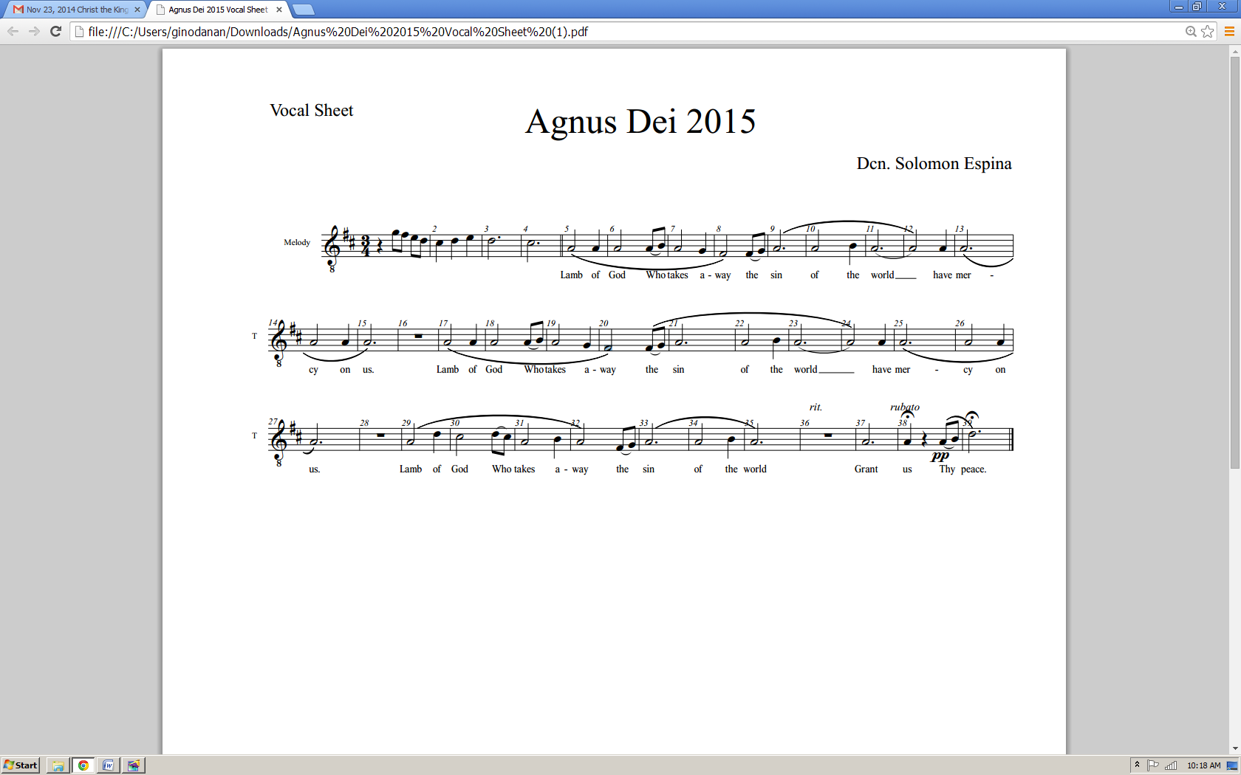

Invitation to Communion

*The Presider elevates the host and the chalice together, saying:*

**Presider: Behold the Lamb of God, behold Him Who takes away the sin of the world. Blessed are those called to the Supper of the Lamb.**

*People*: *Lord, I am not worthy that You should enter under my roof, but say only the word and my soul shall be healed.*

**Presider: The gifts of God for the people of God:**

**Take them in remembrance that Jesus died for you, and feed on Him in your hearts with thanksgiving.**

The Ministration of Communion

**ONLY BY GRACE**

***(Gerrit Gustafson; c. Hosanna! Music)***

*Verse)*

*Only by grace can we enter, only by grace can we stand;*

*Not by our human endeavor, but by the Blood of the Lamb.*

*Into Your presence You call us, You call us to come;*

*Into Your presence You draw us,*

*and now by Your grace we come,*

*Now by Your grace we come.*

*Chorus)*

*Lord, if You mark our transgressions,*

*who would stand?*

*Thanks to Your grace we are cleansed*

*by the Blood of the Lamb;*

*Lord, if You mark our transgressions,*

*who would stand?*

*Thanks to Your grace we are cleansed*

*by the Blood of the Lamb.*

*CODA)*

*Now by Your grace we come, now by Your grace we come.*

**BE MAGNIFIED**

***(Lynn DeShazo; c. Hosanna! Music)***

*1)*

*We have made You too small in our eyes: O Lord, forgive us;*

*And we have believed in a lie that You were unable to help us*

*But now, O Lord, we see our wrong,*

*Heal our hearts and show Yourself strong;*

*And in our eyes and with our song,*

*O Lord, be magnified, O Lord, be magnified.*

*Chorus)*

*Be magnified, O Lord, You are highly exalted;*

*And there is nothing You can’t do,*

*O Lord, our eyes are on You.*

*Be magnified, O Lord, be magnified.*

*2)*

*We have leaned on the wisdom of men: O Lord, forgive us;*

*And we have responded to them*

*instead of Your light and Your mercy.*

*But now, O Lord, we see our wrong,*

*Heal our hearts and show Yourself strong;*

*And in our eyes and with our song,*

*O Lord, be magnified, O Lord, be magnified.*

Post-Communion Prayer

**Presider: Let us pray.**

***All: Almighty and everliving God, we thank You for feeding us with the spiritual food of the most precious Body and Blood of Your Son, our Savior Jesus Christ; and for assuring us in these holy mysteries that we are living members of the Body of Your Son, and heirs of Your eternal kingdom.***

***And now, Father, send us out to do the work You have given us to do, to love and serve You as faithful witnesses of Christ our Lord.***

***To Him, to You, and to the Holy Spirit, be honor and glory, now and forever. Amen.***

Blessing

*Miter on.*

**Bishop: The Lord be with you.**

*People: And with your spirit.*

**Bishop: Our help is in the Name of the Lord.**

*People: The maker of heaven and earth.*

Deacon: Bow your heads and pray for God’s blessing.

**Presider: The peace of God, which passes all understanding, keep Your hearts and minds in the knowledge and love of God, and of His Son Jesus Christ our Lord. And the blessing of God Almighty** ✠ **the Father, the Son, and the Holy Spirit, be with you always. *Amen.***

*OR*

**Bishop: Remember the Gospel. God was in Christ Jesus reconciling the world to himself, not counting men’s sins against them. God loves you. God has forgiven you. God is not angry at you. And God will never leave you, nor forsake you. And the blessing of God Almighty, the Father** ✠ **and the Son** ✠ **and the Holy Spirit** ✠ **be with you this day and forever.**

Recessional

**FOREVER GRATEFUL**

***(Mark Altrogge;***

***c. People of Destiny Music)***

*Chorus)*

*And I’m forever grateful to You.*

*I’m forever grateful for the cross;*

*I’m forever grateful to You*

*That You came to seek and save the lost.* Dismissal

Deacon: Go in peace glorifying the Lord by your life.

**People: *Thanks be to God. Amen.*** ✠